Black Lives Matter
Name of student
Institution
Date

Black Lives Matter

How do we stop police brutality?
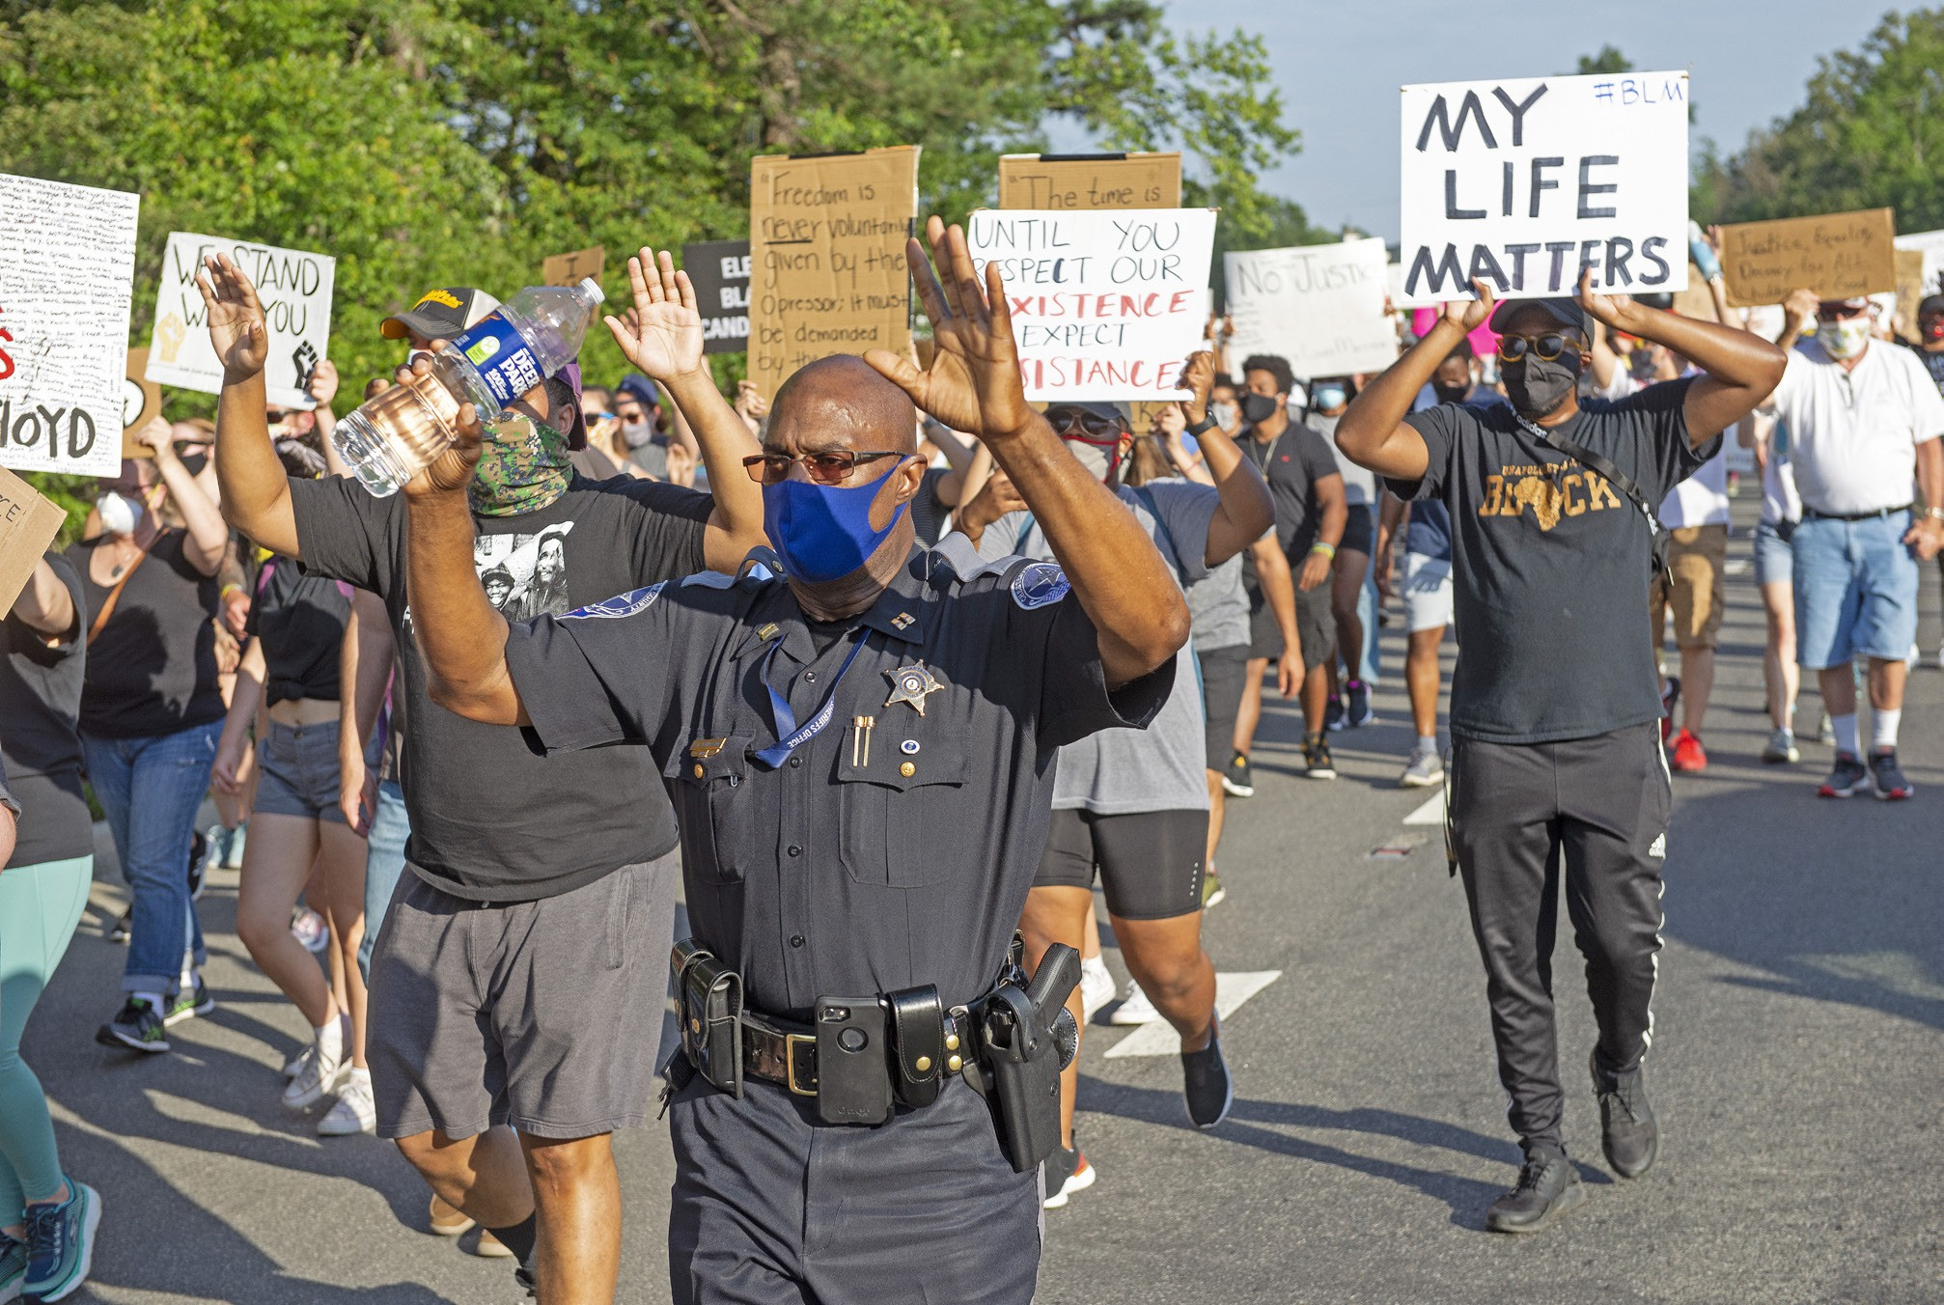
Figure 1, (Chesterfield observer, 2014).

In the year 2013, Alicia Garza, Patrisse Cullors, and Opal Tomenti, female activists responded to the killing of Trayvon Martin by George Zimmerman using the hashtag #blackLivesMatter. At the same time, defenders in Florida worked on ending Angela Corey’s reign as a state attorney for failing to convict Gorge Zimmerman and persecuting a black woman Marissa Alexander who shot her abusive husband but did not hurt anyone in the scene. This movement progressively gained popularity in 2014 and 2015. This slogan has been used throughout the decade and cemented the role of social media in activists’ movements. This movement was more for human rights than it was for civil rights. Black Lives Matter was directed towards amplifying anti-racism across the state and ensuring black people are free from dehumanization. This movement was an affirmation for black people’s humanity in the face of oppression on basis of their race. By 2015, this movement had achieved in making presidential candidates reckon with a legacy of racism and police brutality (Glaude, 2017).
This question lies in the histography category of social sciences. On the years 2013 to 2015, I was living in the states with my parents. At the time there were news reports on the riots and police brutality. I witnessed a couple of riots with people with customized shirts written #BlackLivesMatter, banners, and even signboards. I remember wanting to join them but my parents could not allow me because it was too risky and I was too young. I particularly remember these events because it was my first time witnessing a riot. This event significantly impacted society's perspective on black people. It educated people on being sensitive to the matters of racism. The matter also addressed the matter of police brutality in the state. This movement worked to ensuring black people can move freely without fear of the police.

References
Chesterfield observer. (2014, April 13). https://www.chesterfieldobserver.com/articles/more-than-1000-march-in-chesterfield-to-protest-police-brutality-voice-support-for-black-lives-matter/.
Glaude, E. S. (2017). James Baldwin and Black Lives Matter. A Political Companion to James Baldwin. https://doi.org/10.5810/kentucky/9780813169910.003.0014

